Programming Poe

Contract Monthly Claim System(CMCS)

Rosebank College

Software Dev

Contents

**Documentation** 2

**Tools needed for this to be done** 2

**UML Class Diagram for Database** 3

**Project Plan** 4

**GUI/UI explanation** 5

**References** 6

# **Documentation**

**What has to be done:**

We are creating a contract monthly system

The main goal of the system is to streamline, automate and bring transparency to the process of submitting and approving monthly payments for contract lectures.

It aims to replace a manual , paper-based , or email-based process that is :

* Complex

Time-consuming

Prone to errors and delays

Lacking transparency(lecturers can’t easily see their claim is in the approval process)

The system will make this process reliable, efficient and user-friendly for all three types of participants.

## **Tools needed for this to be done**

* Visual studio code(Where you will work on your WPF )
* Draw.io(to draw your diagrams)
* Github(where your code is stored , also can be used to deploy your completed version of your system through github pages )
* Github desktop(Helps you to clone , push , fetch and pull your code from github)
* Stackoverflow, ChatGBT , Deepseek (these platforms help you to understand ad breakdown your code when needed , especially good for helping you better understand what is required of you and how to achieve those requirements)
* Microsoft Sql sever management (This is where you will store your data , basically this is a database where you can see, manage and control your data)

## **UML Class Diagram for Database**

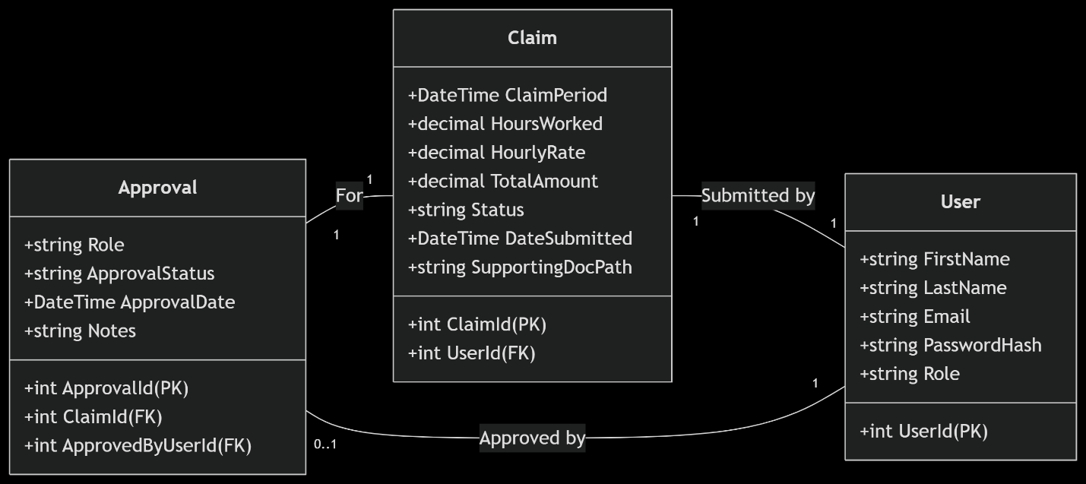

## **Project Plan**

Phase 1: Planning and requirements

Phase 2 : Database Design

Phase 3 : UI design

* WPF will be used in this case
* With various control tools such as DataGrid, TextBox ,ComboBox , DatePicker etc…

Phase 4: Core Development

* This is where everything comes together

Phase 5: Testing and debugging

Phase 6: Deployment

## **GUI/UI explanation**

So for the GUI I am going to use c# to be specific I am going to use the WPF class in where I’ll have a main WPF and then have multiple pages connected to the WPF also WPF is also a class within the c# . To explain it simply its like when you have a html file theirs the nav bar inside the nav bar theirs home,about, contact etc.. where you can click on them and they will take you to their respective web pages that is the same concept that I am trying to implement within this WPF the Pages class will add as an extension of the WPF.

# **References**

ChatGPT. (2025). *ChatGPT*. [online] Available at: <https://chatgpt.com/c/68bea40e-d69c-8324-8e8e-2f37800943f5> [Accessed 9 Sep. 2025]

‌

Deepseek.com. (2025). *DeepSeek*. [online] Available at: <https://chat.deepseek.com/a/chat/s/b84c4cc8-9107-4c7a-b2e2-9e5a865a2c54> [Accessed 9 Sep. 2025].

Yahoo.com. (2018). *db schema - Yahoo Search Results*. [online] Available at: <https://search.yahoo.com/search?fr=mcafee&type=E210US714G0&p=db+schema> [Accessed 9 Sep. 2025].

‌

‌